BEST FEATURE EXPLAINATION

In Feature 1 and Feature 2 we can classify both labels 1 and 2 perfectly. As from the first plot shown below all elements with label 1 are within a circle of radius 4 with center as origin and all elements with label 2 are in between concentric circles of radius 4 and 8. And by using PCA we got results shown in second plot there also the data of label 1 and 2 are not merging at all and it is completely different from the other plots.

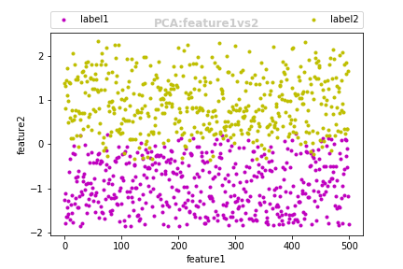
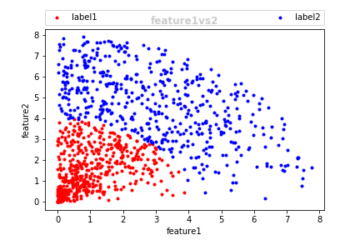
Therefore we can conclude that feature 1 and 2 are the best features to classify labels 1 and 2 perfectly.

